EXP 19 : SIMULATION AND ANALYSIS OF GSM COMMUNICATION SYSTEM WITH TIME DIVISION MULTIPLE ACCESS (TDMA ) USING MATLAB
SOFTWARE USED : MATLAB SOFTWARE
CODE :
clc; clear; close all

N=8; slots=8; bits=randi([0 1],1,N);
tdma=zeros(slots,N);

for k=1:N
tdma(k,k)=bits(k);
end

figure;
subplot(2,1,1)
stem(bits,'filled'); grid on
title('Input Data of GSM Users')
xlabel('User Number'); ylabel('Data Bit')

subplot(2,1,2)
imagesc(tdma); colormap(gray); colorbar
title('GSM TDMA Time Slot Allocation')
xlabel('User Number'); ylabel('Time Slot')

disp('GSM TDMA Simulation')
disp('User Time Slot Data Bit')
disp([(1:N)' (1:N)' bits'])
fprintf('Total Users = %d\n',N);
fprintf('TDMA Time Slots = %d\n',slots);

MODEL GRAPH :
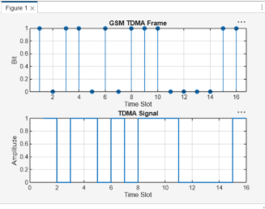

RESULT :
